Lab-Configure Privileged Identity Management for Azure AD roles

Lab scenario

A Privileged role administrator can customize Privileged Identity Management (PIM) in their Azure Active Directory (Azure AD) organization, including changing the experience for a user who is activating an eligible role assignment. You must become familiar with configuring PIM.

Estimated time: 30 minutes

Exercise 1 - Configure Azure AD role settings

Task 1 - Open role settings

Follow these steps to open the settings for an Azure AD role.

1. Sign in to the [https://portal.azure.com](https://portal.azure.com/) as a Global administrator.
2. Search for and then select **Azure AD Privileged Identity Management.**
3. In the Privileged Identity Management page, in the left navigation, select **Azure AD roles.**
4. On the Quick start page, in the left navigation, select **Settings.**

[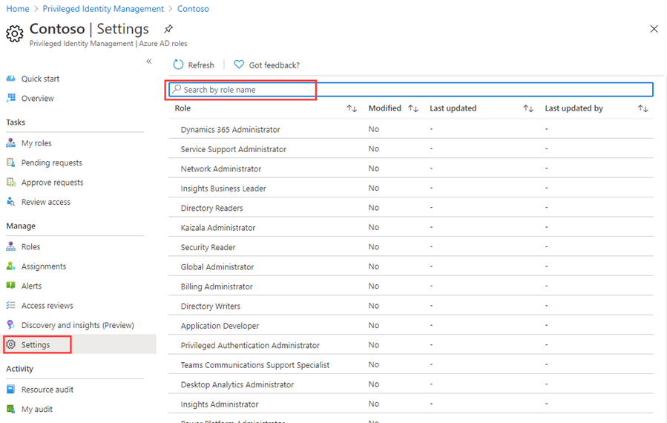](https://microsoftlearning.github.io/SC-300-Identity-and-Access-Administrator/Instructions/Labs/media/lp3-mod3-pim-ad-roles-settings.png)

1. Review the list of roles and then, in the **Search by role name**, enter **compliance**.
2. In the results, select **Compliance Administrator**.
3. Review the role setting details information.

Task 2 - Require approval to activate

If setting multiple approvers, approval completes as soon as one of them approves or denies. You cannot require approval from at least two users. To require approval to activate a role, follow these steps.

1. In the Role setting details page, on the top menu, select **Edit**.

[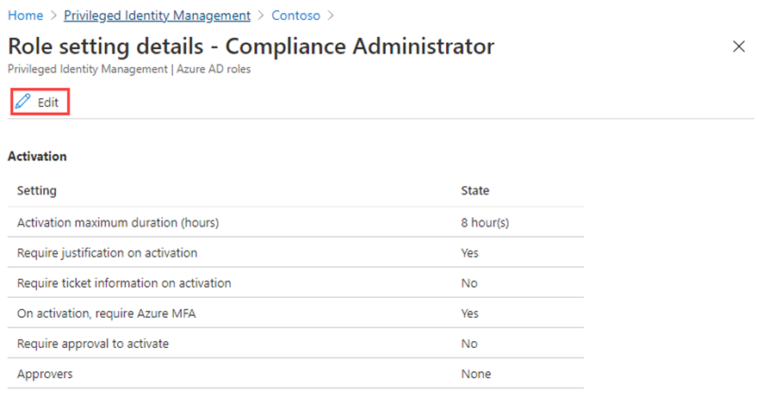](https://microsoftlearning.github.io/SC-300-Identity-and-Access-Administrator/Instructions/Labs/media/lp4-mod3-pim-edit-compliance-role.png)

1. In the Edit role setting – Compliance Administrator page, select the **Require approval to activate** check box.
2. Select **Select approvers**.
3. In the Select a member pane, select your administrator account and then select **Select**.

[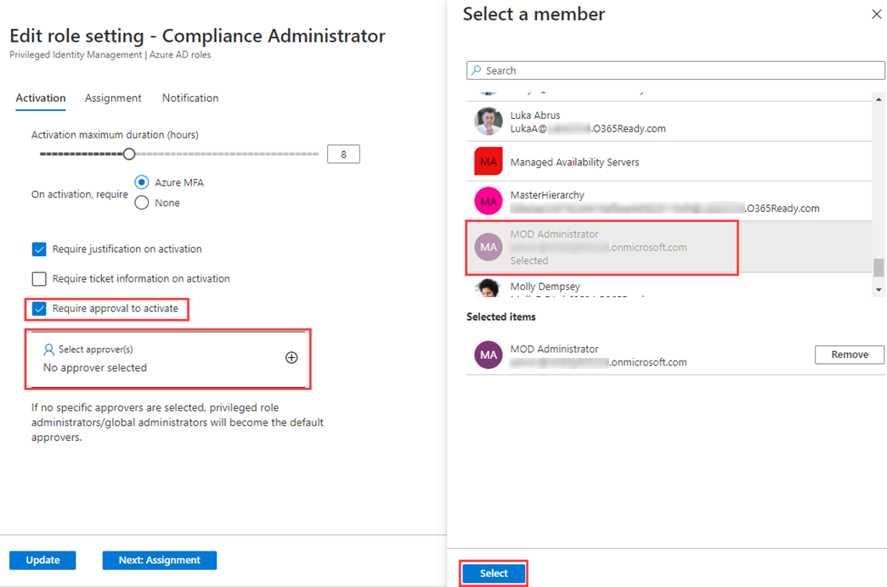](https://microsoftlearning.github.io/SC-300-Identity-and-Access-Administrator/Instructions/Labs/media/lp4-mod3-pim-add-approver.png)

1. Once you have configured the role settings, select **Update** to save your changes.

Exercise 2 - PIM with Azure AD roles

Task 1 - Assign a role

With Azure Active Directory (Azure AD), a Global administrator can make permanent Azure AD admin role assignments. These role assignments can be created using the Azure portal or using PowerShell commands.

The Azure AD Privileged Identity Management (PIM) service also allows Privileged role administrators to make permanent admin role assignments. Additionally, Privileged role administrators can make users eligible for Azure AD admin roles. An eligible administrator can activate the role when they need it, and then their permissions expire once they’re done.

Follow these steps to make a user eligible for an Azure AD admin role.

1. Sign in to [https://portal.azure.com](https://portal.azure.com/) using a Global Administrator account.
2. Search for and then select **Azure AD Privileged Identity Management.**
3. In the Privileged Identity Management page, in the left navigation, select **Azure AD roles.**
4. On the Quick start page, in the left navigation, select **Roles**.
5. On the top menu, select **+ Add assignments.**

[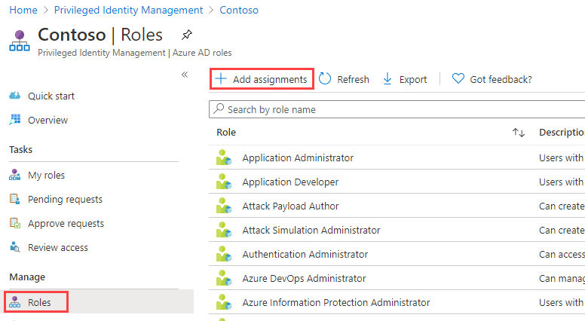](https://microsoftlearning.github.io/SC-300-Identity-and-Access-Administrator/Instructions/Labs/media/lp4-mod3-pim-assign-role.png)

1. In the Add assignments page, on the **Membership** tab, review the settings.
2. Select the **Select role** menu and then select **Compliance Administrator**.
3. You can use the **Search role by name** filter to help located a role.
4. Under **Select member(s),** select **No members selected**.
5. In the Select a member pane, select **Miriam Graham** and then select **Select**.

[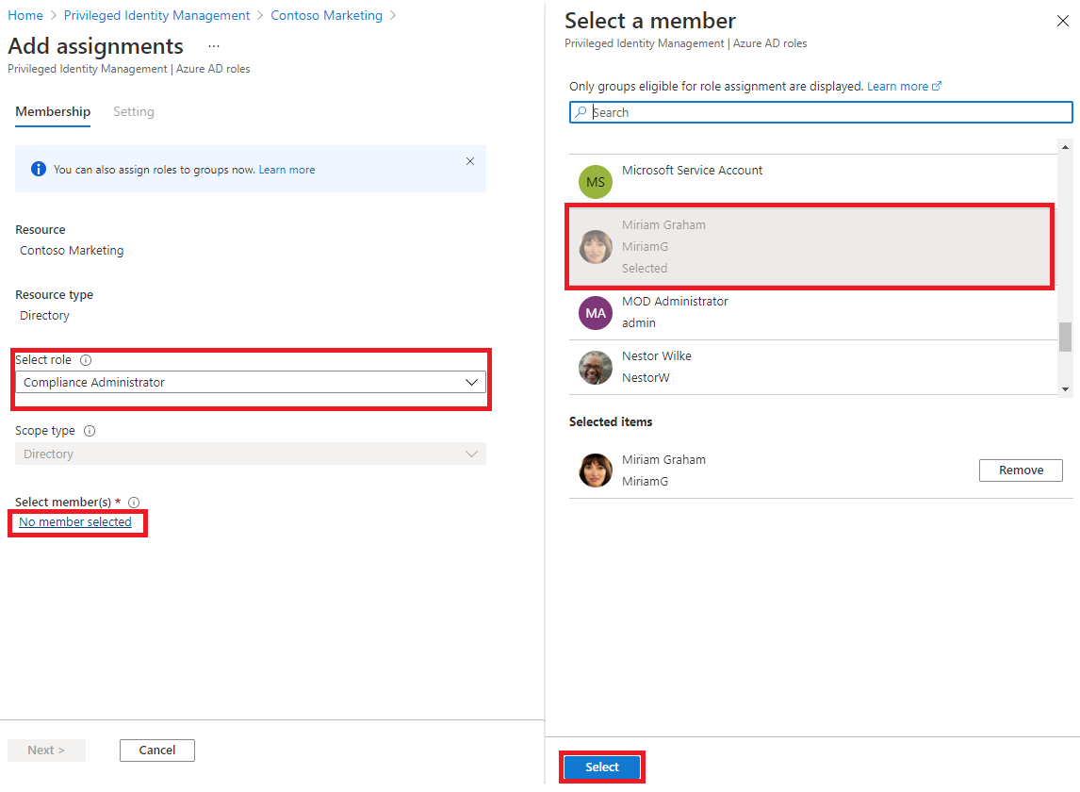](https://microsoftlearning.github.io/SC-300-Identity-and-Access-Administrator/Instructions/Labs/media/lp4-mod3-pim-add-role-assignment.png)

1. In the Add assignments page, select **Next**.
2. On the **Settings** tab, under **Assignment type**, review the available options. For this task, use the default setting.
   * Eligible assignments require the member of the role to perform an action to use the role. Actions might include performing a multi-factor authentication (MFA) check, providing a business justification, or requesting approval from designated approvers.
   * Active assignments do not require the member to perform any action to use the role. Members assigned as active have the privileges always assigned to the role.
3. Review the remaining settings and then select **Assign**.

Task 2 - Log in with Miriam

1. Open a new InPrivate browser window.
2. Connect to the Azure Portal (https://portal.azure.com).
3. If it opens with a user logged in, Select on their name in the upper-right corner and select **Sign in as a different account**.
4. Log in a Miriam.

| Field | Value |
| --- | --- |
| Username | **MiriamG@** <<your domain.onmicrosoft.com>> |
| Password | Enter the tenant’s admin password(Refer the Lab Resources tab to retrieve the tenant admin password) |

1. Close the **Welcome to Azure dialog**.
2. From the **Search resource, services, and docs** bar look for Azure Active Directory, and open the page.
3. On the **Overview** page, look for the **My feed**.
4. Select **View Profile** under Miriam Graham’s name; this with open Miriam’s profile page.
5. Select **Assigned roles** then select **Eligible assignments**.
6. Notice that the **Compliance Administrator** role is now available to Miriam.

Task 3 - Activate your Azure AD roles

When you need to assume an Azure AD role, you can request activation by opening **My roles** in Privileged Identity Management.

1. From the **Search, resources, services, and docs** bar, look for Privileged.
2. Open the **Azure AD Privileged Identity Management** page.
3. On the Privileged Identity Management page, in the left navigation menu, select **My roles.**
4. In the My roles page, review the list of eligible assignments.

[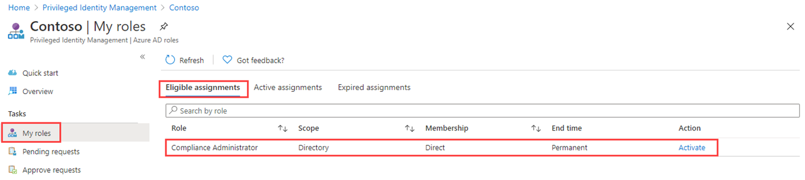](https://microsoftlearning.github.io/SC-300-Identity-and-Access-Administrator/Instructions/Labs/media/lp4-mod3-my-roles.png)

1. In the Compliance Administrator role row, select **Activate**.
2. In the Activate – Compliance Administrator pane, select **Additional verification required** and then follow the instructions to provide additional security verification. You are required to authenticate only once per session.

[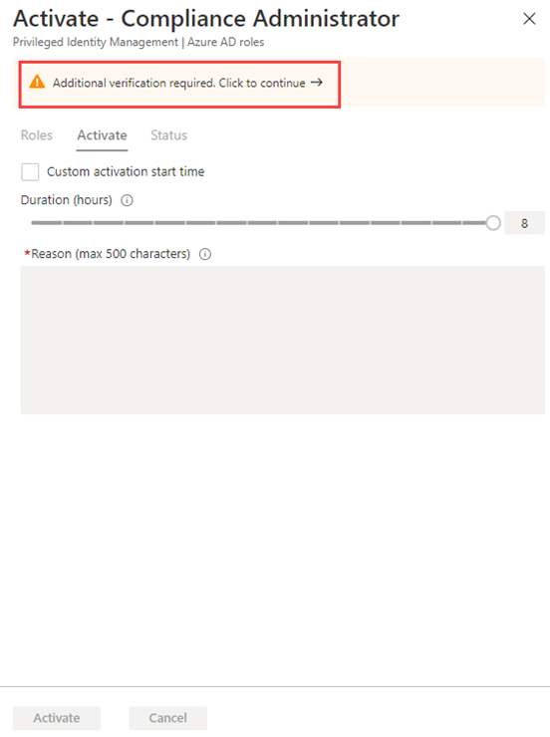](https://microsoftlearning.github.io/SC-300-Identity-and-Access-Administrator/Instructions/Labs/media/lp4-mod3-pim-activate-role.png)

**Verification** - Based on our current lab environment configuration, you will be required configure MFA and log in successfully.

1. After you have completed the additional security verification, in the Activate – Compliance Administrator pane, in the **Reason** box, enter the **This is my justification for activating this role**.

**Important Note** - the principal of least prvilege, you should only activate the account for the amount of time you need it. If the work needed to be done, only takes 1.5 hours, then set the duration to two hours. Similarily, if you know that you won’t be able to do the work until after 3pm, choose a Custom activation time.

1. Select **Activate**.

Task 4 - Assign a role with restricted scope

For certain roles, the scope of the granted permissions can be restricted to a single admin unit, service principal, or application. This procedure is an example if assigning a role that has the scope of an administrative unit.

1. Remember to close out the browser windows for MiriamG, then open the Azure Portal as your administrator account.
2. Browse to the Privileged Identity Management page, and in the left navigation menu, select Azure **Azure AD roles.**
3. Select **Roles**.
4. In the Roles page, on the top menu, select **+ Add assignments.**
5. In the Add assignments page, select the **Select role** menu and then select **User administrator.**
6. Select the **Scope type** menu and review the available options. For now, you will use the **Directory** scope type.

**Tip** - Go to <https://docs.microsoft.com/en-us/azure/active-directory/roles/admin-units-manage> for more information about the administrative unit scope type.

1. As you did when assigning a role without a restricted scope, you would add members and complete the settings options. For now, select **Cancel**.

Task 5 - Update or remove an existing role assignment

Follow these steps to update or remove an existing role assignment.

1. In the Open Azure AD Privileged Identity Management > Azure AD roles page, in the left navigation, select **Assignments**.
2. In **Assignments** list, for Compliance Administrator, review the options in the **Action** column.

[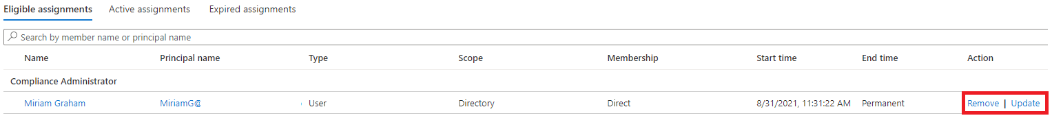](https://microsoftlearning.github.io/SC-300-Identity-and-Access-Administrator/Instructions/Labs/media/lp4-mod3-pim-edit-role-assignments.png)

1. Select **Update** and review the options available in the Membership settings pane. When complete, close the pane.
2. Select **Remove**.
3. In the **Remove** dialog box, review the information and then select **Yes**.